1. 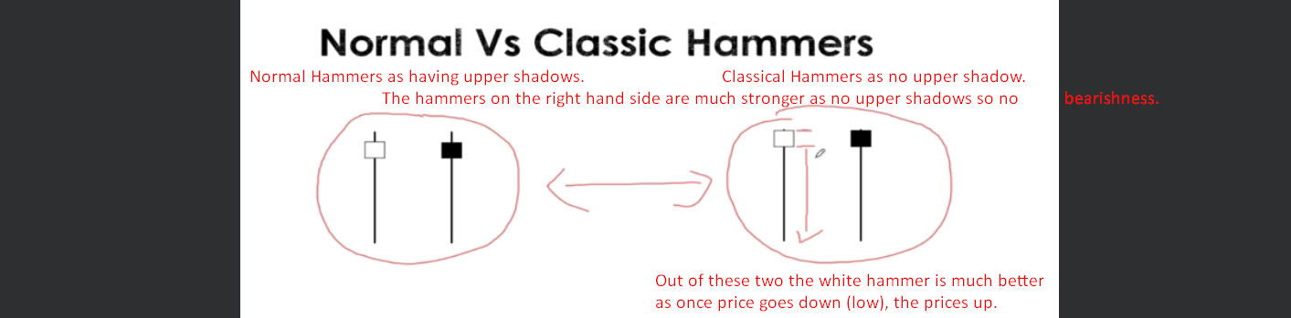
2. A graph with numbers and lines

   Description automatically generated with medium confidence